This project is about taking the shortest path to arrive to your location so we used 4 algorithms to see which one is the fastest and gives a good result.
The algorithms that we used are:
-Dijkstra’s Algorithm
-Bellman-Ford Algorithm
-Floyd-Warshall Algorithm
-A* (A-Star) Algorithm

Dijkstra’s Algorithm
Dijkstra's algorithm is one of the algorithms most people use daily; it's mostly used in GPS apps.
How does it work?
First, it sets the distance to the start node to 0 and all other nodes to infinity after that, it will pick the unvisited node with the smallest distance, then it looks at all neighbors of that node and Calculate the distance to those neighbors through the current node and update the path that it will take (If this new path is shorter than the previous path, then it will update the path that it will take), So the process of this algorithm is:

Bellman-Ford Algorithm
Bellman-Ford Algorithm it’s a algorithm that can deal with negative weights its more powerful than Dijkstra's algorithm, but it's not as functional in Ur project because it takes a long time to
give the output, and the negative weight is rare in node maps. This algorithm is also used in GPS apps.
How does it work?
As Dijkstra's algorithm it look at all the possible ways to go to its location, adding to that,
Bellman-Ford Algorithm looks at another thing, which is a path that contains a negative value. By negative, I mean it can make the time of arrival shorter, like using shortcuts.

Floyd-Warshall Algorithm
Floyd-Warshall Algorithm is the slowest one and will not be useful for our project. However it’s a reliable way to look for the shortest path and is mostly used in Networking and
Telecommunications.
How does it work?
Floyd-Warshall Algorithm it visit all the nodes and comparing which path is the best path. The thing that makes it slow is that it visits all the nodes.

A* (A-Star) Algorithm
A* is the fastest algorithm, but its risky this algorithm is used at pathfinding and graph traversal where it need to find the result fast.
How does it work?
First it looks at the destination node thin it go to it without any seeing any other path. The downside of it is that it may go to a dead end without knowing that the path it taking is not correct.

Samples
A* samples
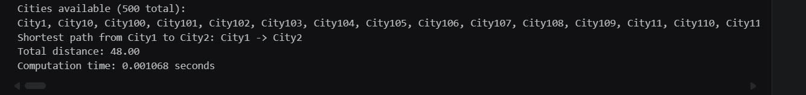
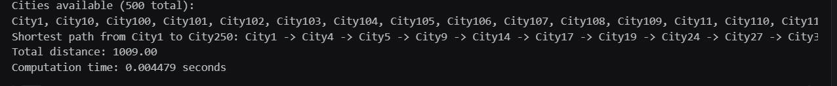
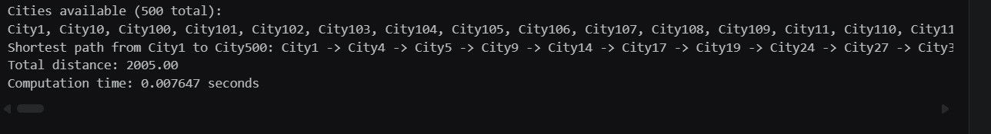

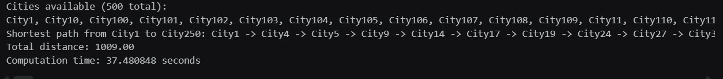
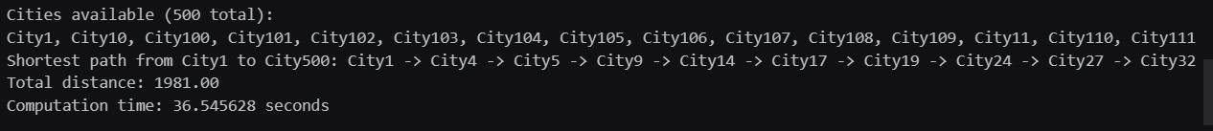
Floyd-Warshall Algorithm samples

Dijkstra’s Algorithm samples

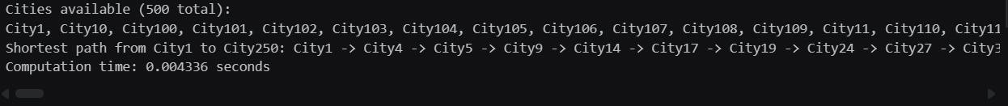

Bellman-Ford Algorithm
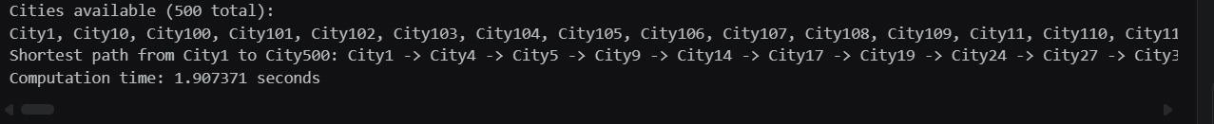
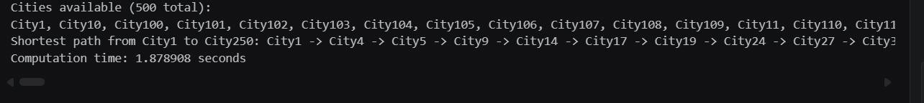

Analysis

So, according to those samples and the algorithm characteristics, Dijkstra’s Algorithm is the best algorithm for our project. A* algorithm and Bellman-Ford Algorithm are average, lastly, Floyd- Warshall Algorithm is the worst algorithm.

summary

Algorithm | Primary Use Case | Key Strength | Main  Weakness | Project Ranking
Dijkstra’s | GPS / Navigation | Always finds the shortest path efficiently. | Cannot handle negative  weights. | Best Algorithm
A (A-Star)* | Games / Fast Pathfinding | Extremely fast; uses a  "guess" to find the goal. | Can get stuck in dead ends if the guess is wrong. | Average Algorithm
Bellman- Ford | Financial Networks | Can handle negative weights  (shortcuts). | Much slower than Dijkstra. | Average Algorithm

Floyd- Warshall | Network Infrastructure | Finds paths between all  nodes at once. | The slowest | Worst  Algorithm

